**Ideation Phase**

**Brainstorm & Idea Prioritization Template**

|  |  |
| --- | --- |
| Date | 1 November 2023 |
| Team ID | 592189 |
| Project Name | Lip Reading Using Deep Learning |
| Maximum Marks | 4 Marks |

**Brainstorm & Idea Prioritization Template:**

Brainstorming provides a free and open environment that encourages everyone within a team to participate in the creative thinking process that leads to problem-solving. Prioritizing volume over value, out-of-the-box ideas are welcome and built upon, and all participants are encouraged to collaborate, helping each other develop a rich amount of creative solutions.

**Problem Statement:**

Lip reading presents challenges due to variations in lip movements, speech speed, and background noise, making it an unreliable communication tool for individuals with hearing impairments. Traditional lip-reading methods, reliant on human interpretation, struggle with consistency and are error-prone due to limited contextual information, necessitating a more reliable and adaptable approach.

**Ideation & Prioritization:**

**Brainstormed Ideas:**

1. **User-Friendly and Accessible Solution:** Develop a user-friendly and accessible solution.
2. **Multi-Lingual Lip Reading:** Implement lip reading for multiple languages.
3. **Cross-Platform Integration:** Integrate lip reading into various communication platforms.
4. **Lip Reading for Autism:** Explore applications for individuals with autism.
5. **Feasibility Considerations:** Assess the feasibility of each idea based on factors like cost, time, effort, and complexity.

**Prioritization:**

* Prioritize based on importance, feasibility, and potential impact.
* Ensure a balance between technical development, user experience, and ethical considerations.
* Consider partnerships, research, user support, and scalability as integral components of the project.

**Reference:**

<https://app.mural.co/t/vit5980/m/vit5980/1698822096797/cef2de3969da01147c7a5ad0c64effdf8d0e4f3c?sender=u7c8fc861750c57df55d93278>

**Step-1: Team Gathering, Collaboration and Select the Problem Statement**

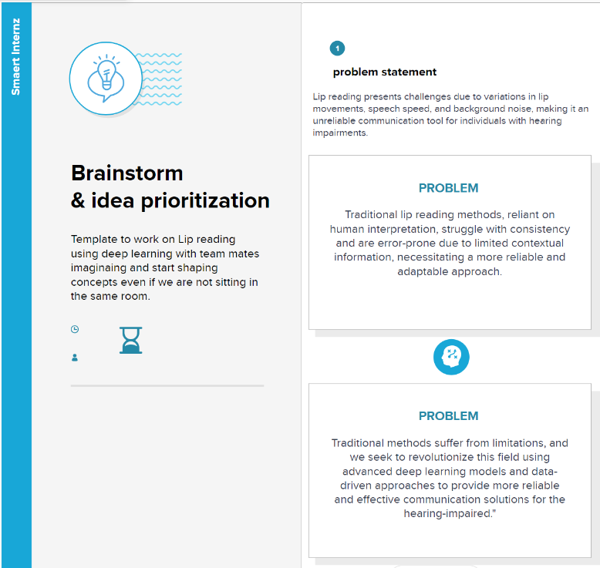

**Step-2: Brainstorm, Idea Listing and Grouping**

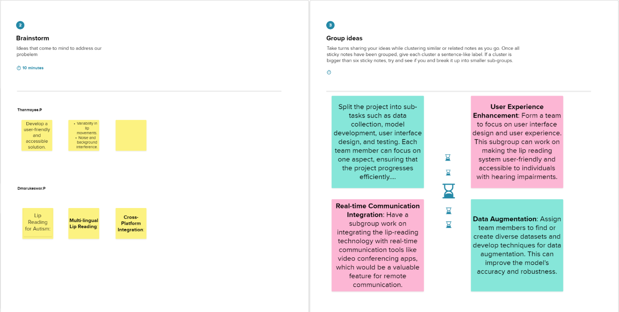

**Step-3: Idea Prioritization**

